***CITI Bike Analysis of 2019 – New York City***

The Citi Bike data includes:

* Trip Duration (seconds)
* Start Time and Date
* Stop Time and Date
* Start Station Name
* End Station Name
* Station ID
* Station Lat/Long
* Bike ID
* User Type (Customer = 24-hour pass or 3-day pass user; Subscriber = Annual Member)
* Gender (Zero=unknown; 1=male; 2=female)
* Year of Birth

Using *Tableau Public software*

* 1. This graph shows the total bike trips in 2019 by month

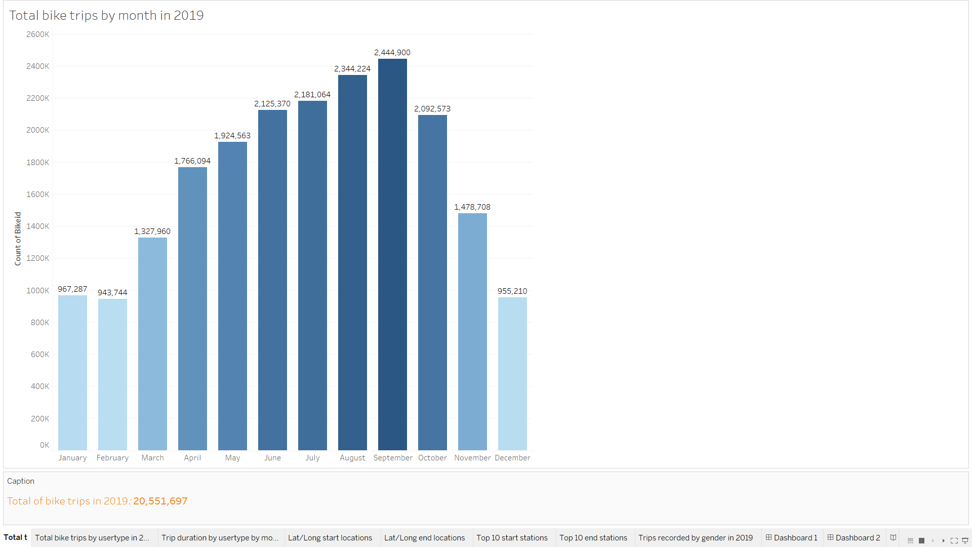

Comment 1: As expected, the weather influences a lot the bike trips in NYC. The summer months of the year are the busiest, with more than 2million bike trips recorded, with the highest in September (2,444,900). In contrast, the winter months are less busy and fall below 1 million bike trips during these months - Dec. through Feb..

* 1. This graph shows the total bike trips by user type in per 2019 – Customer vs Subscriber

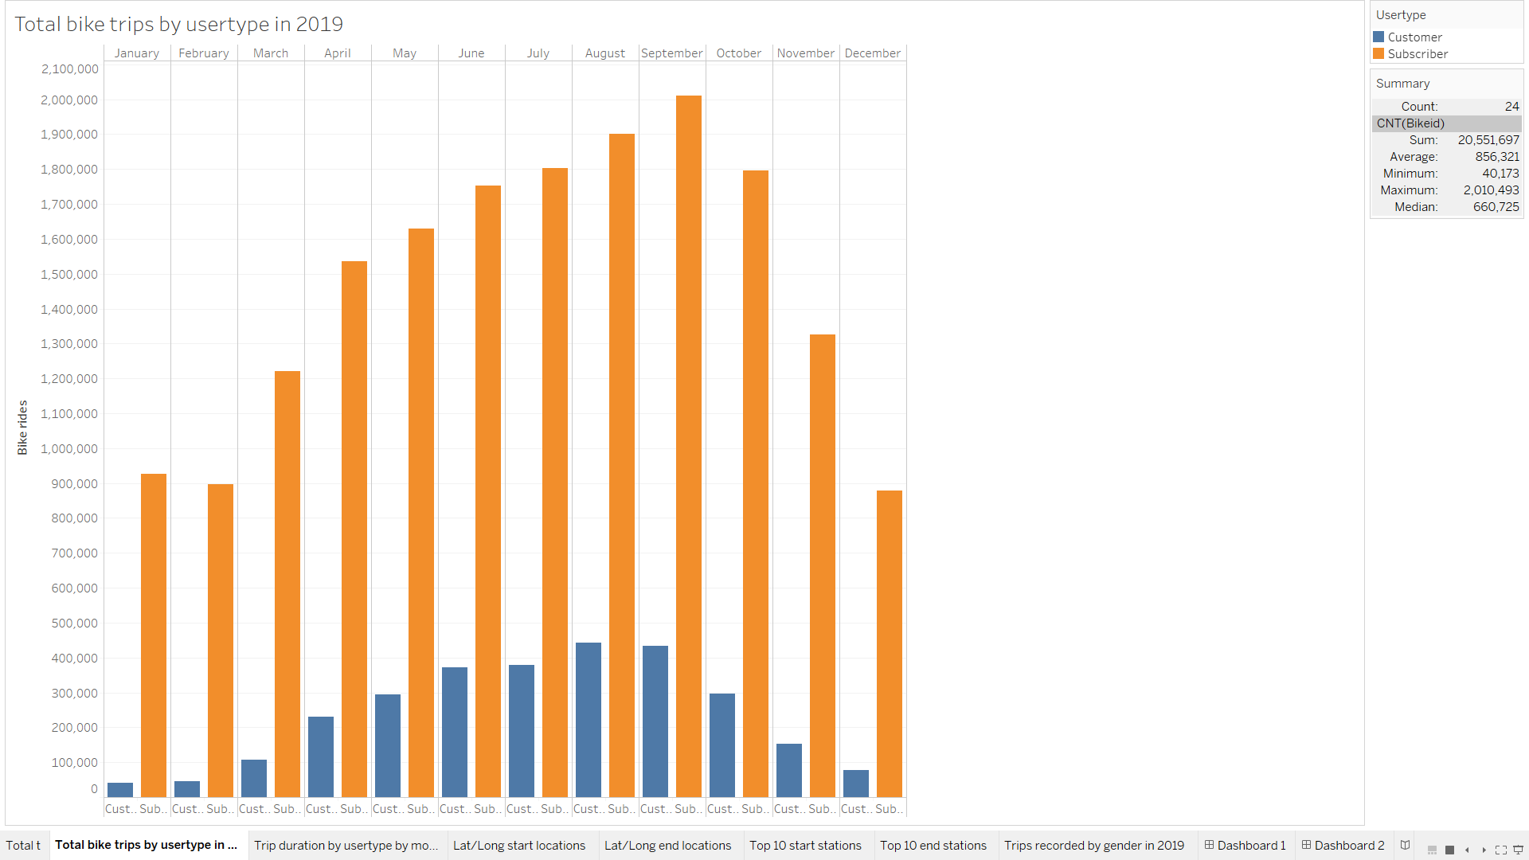

* 1. This graph shows the trip duration (in seconds) per month in 2019 by user type

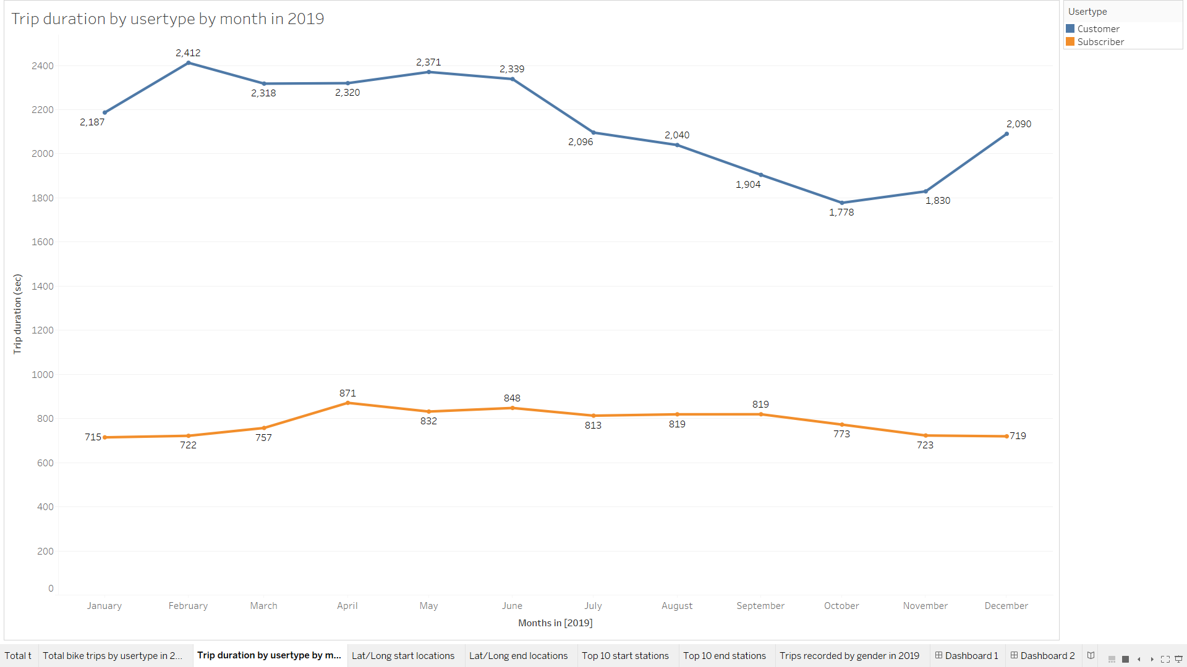

* 1. This graph shows the map of start stations of bike trips in NYC

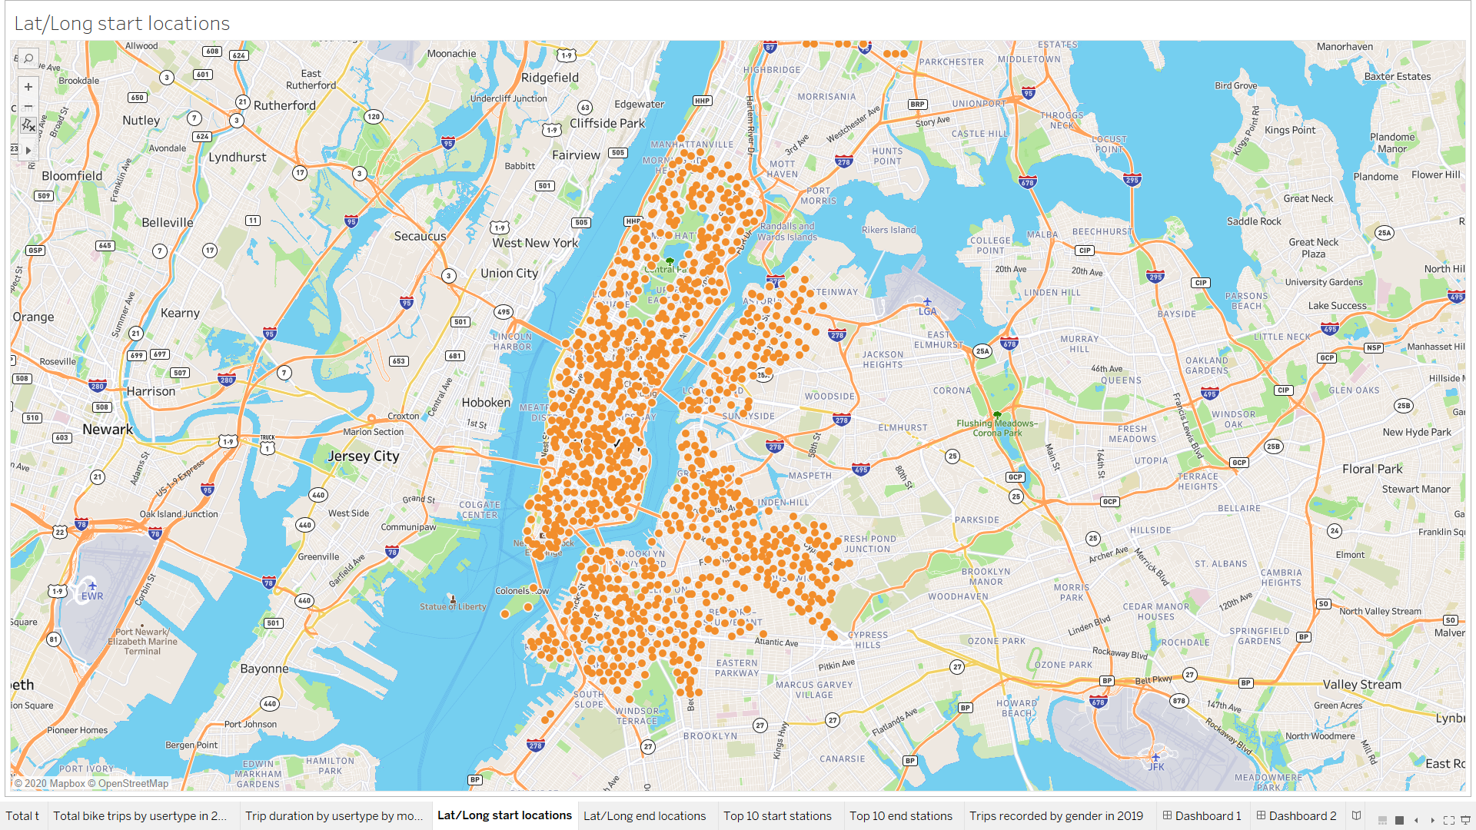

* 1. This graph shows the map of end stations of bike trips in NYC

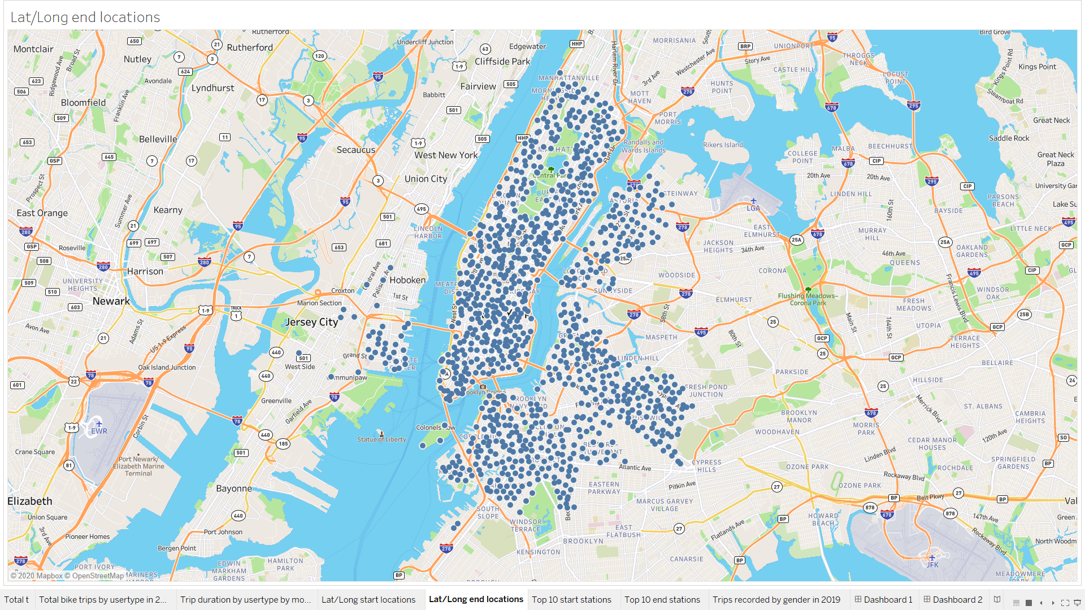

* 1. This graph shows the top 10 start stations by volume of bikes

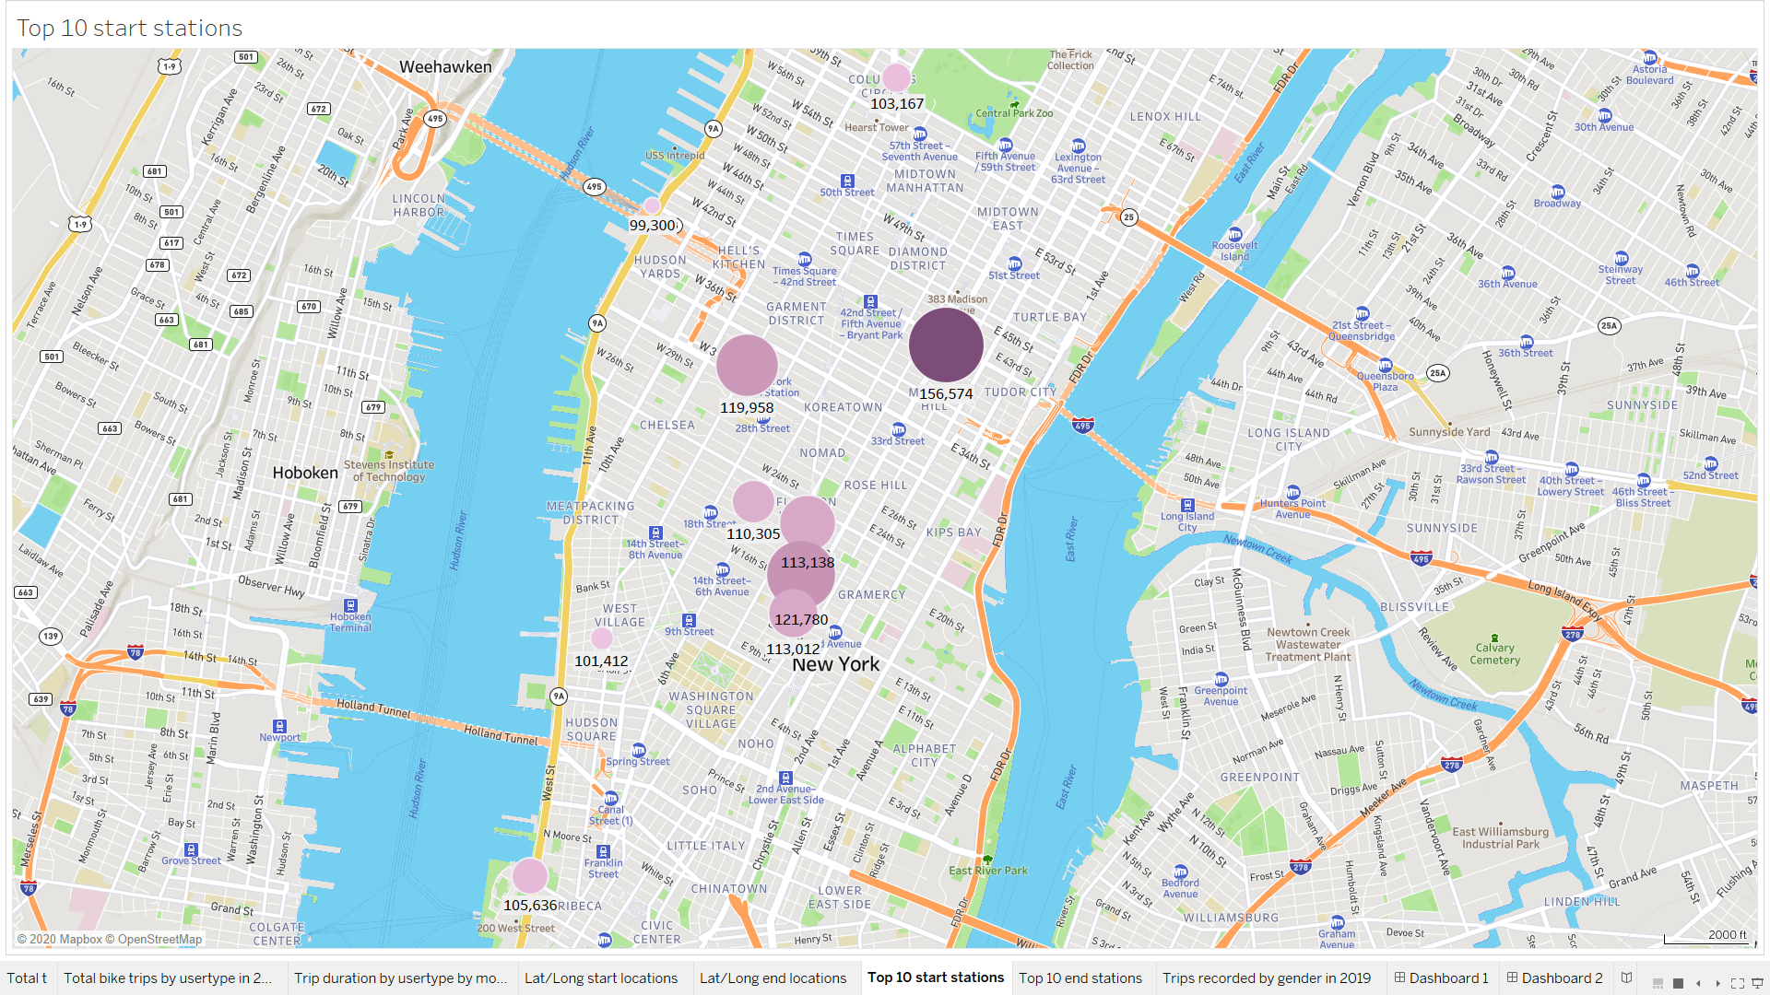

* 1. This graph shows the top 10 end stations by volume of bikes

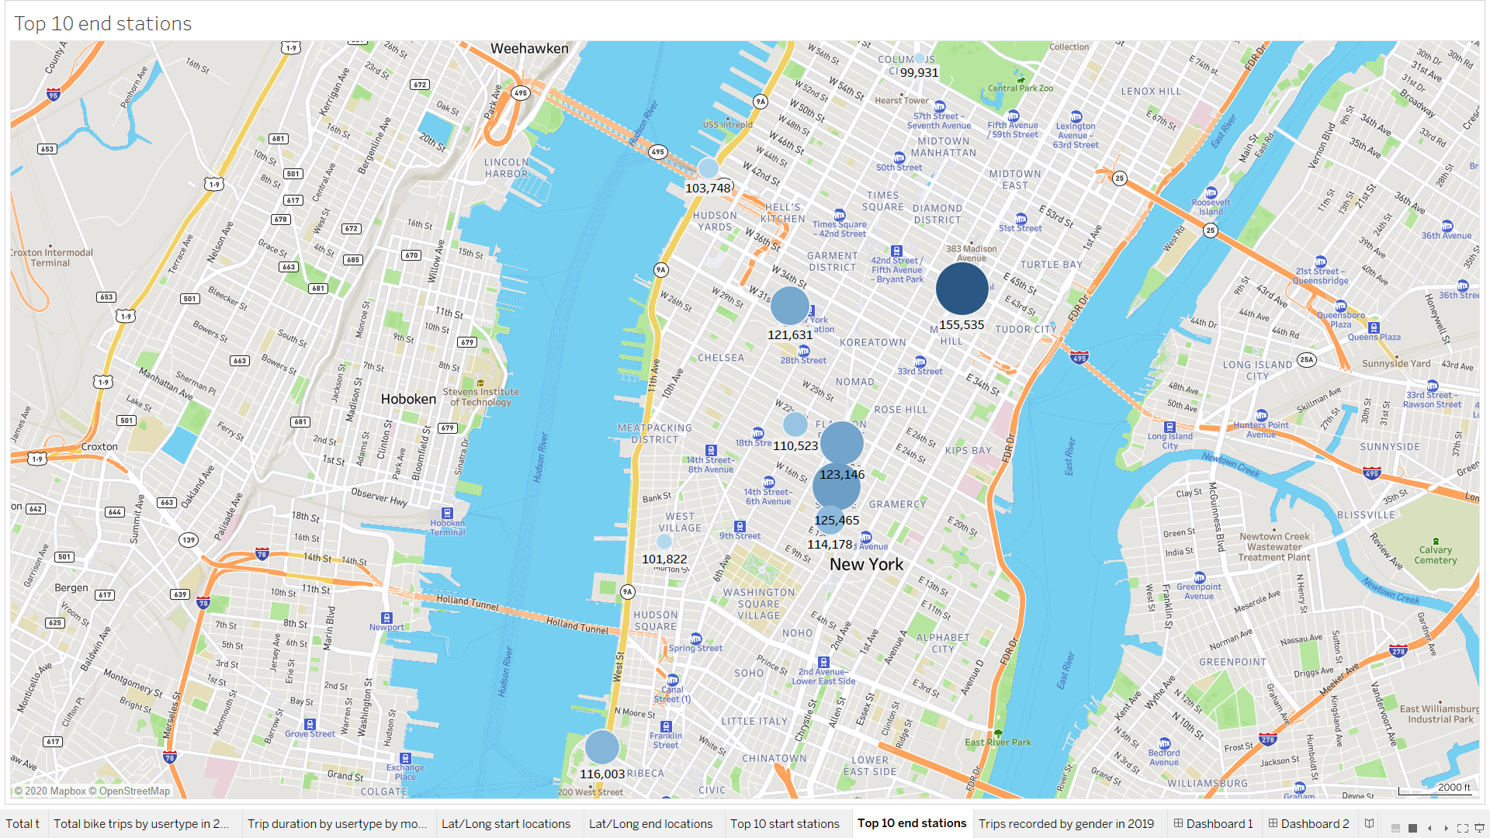

* 1. This graph shows the total bike trips in 2019 per gender

